Statutes for ISSCC (draft 2.0)

Chapter 1 General Principles

Article 1 Title
The International Smart Sustainable City Club，hereinafter as “ISSCC”.

Article 2 Nature
ISSCC is a non-profit organization jointly and voluntarily established by cities of various levels, researching institutes, enterprises and NGOs interested in smart sustainable city standardization.
Article 3 Objectives
ISSCC will promote the principle of “applying standards, sharing policies, exchanging results, and communication between enterprises” among its members, through the application of ISO37101 and other ISO/TC268 deliverables, to achieve the following objectives:
- Organize a Global City Network piloting ISO/TC268 standards, build an exchanging platform for cities on sustainable development, and improve sustainability and efficiency of governance for member cities.
- Actively participate ISSCC events in conjunction with ISO/TC 268 meetings, collect feedbacks and suggestions on urban sustainable development, and offer recommendations for ISO TC 268 standards.
- Promote international cooperation among member cities, through standard implementation, exchanging and communication. Also contribute to economic collaborations between cities.

Chapter 2 Work Scope

Article 4 Main Tasks
ISSCC will actively involve worldwide cities of various levels and national representatives, with the main tasks as below:
- Hosting congress and seminars, establishing liaisons among mayors;
- Constructing a communication platform (e.g. Construction 21);
- Helping members to become international smart sustainable pilots of ISO 37101 and then ISO 371XX series;
- Support cities for auto-evaluation of their practices and progresses;
- During the implementation of ISO/TC268 standards (especially ISO37101), provide support and guidance through different stages:
Experimentation stage: upon receiving application, with a statement letter showing the political leadership commitment, an experimentation proof will be awarded after approval.
DEMO stage: upon accomplishing the following: 3 No. of implementation progress presentations to ISO/TC268 WG1; recognition letter from NSB; 1 on-site review session involving at least 3 country experts from ISO TC 268; 1 self-evaluation report of the ISO 37101 experiment according to the ISSCC released template, with written contribution on feedback of ISO TC 268 standards and expression of needs; a DEMO proof will be awarded after approval.
Pilot Stage: upon receiving a certifying report with certification awarded by a third-party recognized by ISO/TC268, a pilot proof will be issued by ISSCC. The city will also be promoted in ISSCC platform.

Chapter 3 Organizational structure and Management
Article 5 Organizational chart
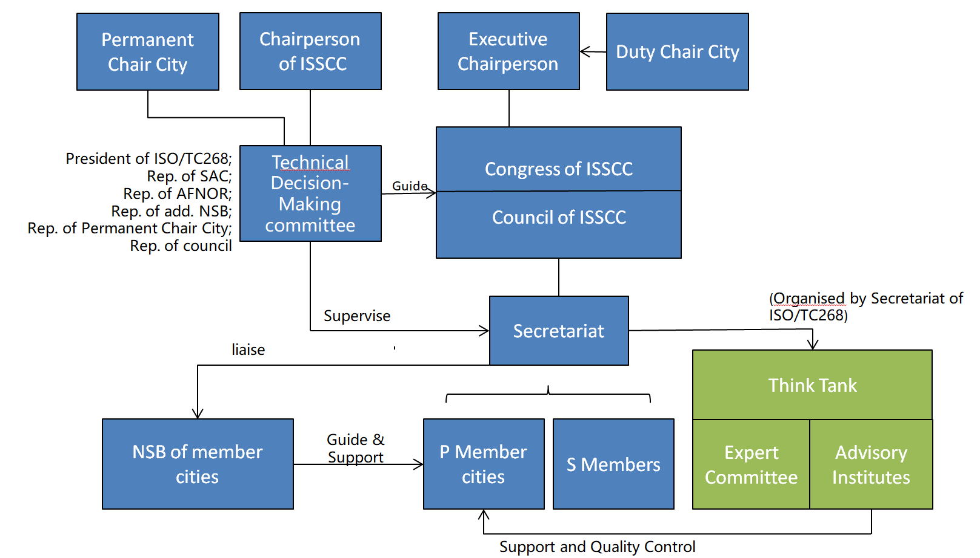

Article 6 Council of ISSCC
The Council of ISSCC is the primary deliberative organ, instructed by the Technical Decision-Making (TDM) Committee, to approve and rectify major decisions for ISSCC. The council members shall meet at least once per year. The council will be responsible for:
- Approve the modification of statutes for ISSCC.
- Review performance of each role listed in Organizational Chart (regularly as in the Statutes), and agree decisions in due course.
- Examine and approve the annual work report of ISSCC.
- Approve the strategic vision of ISSCC produced by the secretariat.
- Audit the financial management and implementation.

Article 7 Technical Decision-Making Committee
The TDM Committee is the primary decision-making organ of ISSCC, in charge of determining major issues, and then be carried out by the Secretariat. The TDM Committee consists of 6 members, representing ISO/TC 268, SAC and AFNOR as founder NSBs, one additional NSB, the Permanent Chair City, and the council. Each TDM committee member serves a term of 5 years, and will be reviewed by the council on a three-year mid-term basis.
The additional NSB will be selected by ISO TC 268 during its plenary, following expression of interest send to the chairperson of ISO TC268 by participating members in ISO TC 268.

Article 8 Congress of ISSCC
The Congress of ISSCC is the general assembly, and shall meet once or twice per year, with the local expenses being beard by the host city. Congress will be responsible for：
- Approval of the propositions from the Council in principle of simple majority;
- Promoting communication of practice and results of the implementation of ISO 371XX and especially ISO 37101 among cities.
- Approval of the nomination of member entry into the council.

Article 9 Chairperson

The Chairperson of ISSCC shall be the chairperson of ISO/TC268.

Article 10 Permanent Chair City

Hangzhou city will serve as the first permanent chair city, assigning a delegate to participate all the TDM meetings and ISSCC events.

There will be a review upon this role by the council every three years. Should there be two consequent 3-year term recommendations for replacement, both the current permanent chair city and all serviced duty chair cities can become candidates, then the congress will decide the next permanent chair city by voting.

Article 11 Duty Chair City & Executive Chairperson

Duty chair city will be nominated every two years. The duty chair city shall appoint its mayor or deputy mayor as the executive chairperson, who will stay available for one additional year to support the new executive chairperson. The executive chairperson will be responsible for:
- participating TDM meetings and tele-conference;
- participating all ISSCC activities during the service term;
- hosting at least one ISSCC congress within 2 years;
- producing ISSCC leaflet supported by the secretariat during the term;
- Producing & maintaining a local language version of ISSCC website;

Article 12 Secretariat

The Secretariat is the standing organ to carry out daily works for ISSCC, and shall report to the TDM committee. The Secretary General needs to be authorized by the Chairperson, and the Secretary will be held by AFNOR, both with a term of 5 years. The Mirror Committee or NSB from the duty chair city will allocate a specific secretary to support the council. In long run, the Secretariat Office will be operated by the standard advisory institute. Its major responsibilities include:
- Drafting and revising the statutes of ISSCC;
- Preparing and convening the Congress of ISSCC;
- Carrying out decisions approved by the Congress of ISSCC;
- Drafting the annual work report of ISSCC;
- Handling the application or withdrawn of ISSCC membership and carrying out preliminary examinations;
- Organising pilot projects for ISO/TC268 standards implementation.
- Organising evaluation for member cities, helping cities with auto-evaluation of their practices and progresses.

Article 13 Think tank
The Think Tank is partner of ISSCC, and will be an independently operated institution parallel to the ISSCC, consisting expert committee and standard advisory institute (one such institute per country). Think tank will assign a delegate in TDM meeting to observe and advice.
The Think Tank will perform as the quality control advisor for piloting ISO 268 standards, by providing technical guidance, support and training services for member cities, on a market-oriented basis.
Article 14 Members of ISSCC
Members of ISSCC, composed with (P)articipating members (local municipal and state-level governments) and (S)upporting members (research institutes, consulting companies and enterprises located within areas of official members).

Chapter 4 Application Procedures

Article 15 Procedure to become a Council Member
- Agree and abide the regulations of ISSCC
- Meet the requirement of fundamental definition & characteristics of city/community according to the sustainable development standards; or National Standardization Bodies for member city countries.
- Willing to participate the Council activities, in line with guidance of Technical Decision-Making(TDM) Committee.
- Willingness expressed to the ISSCC Chairperson, and be nominated jointly by the Chairperson and Secretariat of ISSCC, then confirmed through the ISSCC Congress.
- The term for council members will be 2 years.

Article 16 Access requirements for TDM Committee
- Agree and abide the regulations of ISSCC.
- Willing to participate the decision-making of major issues of ISSCC.
- Consists of 6 members, representing ISO/TC 268, SAC, AFNOR, one additional NSB, the permanent chair city, and one council representative.
- Be determined by each party, with a term of five years.
- Performance to be reviewed by the council every three years.

Article 17 Procedure to become/renew a P member of ISSCC
- Form to be filled and signed and submitted online;
- Secretariat office to pre-qualify and circulate;
- Approved by simple majority of Council Members;
- Signed by the Chairperson and membership rectified;
- Experimentation letter issued;
- International Experimentation City plate issued;

Article 18 Procedure to become/renew an S member of ISSCC
- (S)upporting members will be organisations, research institutes, consulting companies and enterprises located within areas of official P members; as well as international organisations;
- S members can make propositions to the Council, whilst having no voting rights. Membership required.
- Form to be filled and signed;
- Return to the secretariat office;
- Approved by 1/3 Council Members;
- Signed by the Chairperson and membership rectified;
- Recognition Letter issued;

Article 19 Withdrawn
Member intends to withdraw from ISSCC shall submit application to the Secretariat, who will pass to all council members. Consequently, the withdrawing will be considered as being effective, and the above-mentioned member will no longer be entitled with any privileges or services in ISSCC.

Chapter 5 Assets management & Principle for using

Article 20 Source of Funding
- Subsidy: Funds are raised through patronage of members;
- Membership: funds are accumulated mainly as membership from council members and ISSCC members;
- Donation;
- Income incurred by carrying out activities or providing services within approved business scope;
- Other legal income.

Article 21 Membership
ISSCC collects membership fees set or adjusted by the Congress. The fee standard shall be approved through vote by principle of majority.

Article 22 Using of funds
Funds of ISSCC shall be used within scope stipulated by this regulation and following an annual budget program; re-allocated funds among members is strictly impossible

Article 23 Financial Management
ISSCC shall establish strict financial management system, to ensure that the accounting data is legal, true, accurate and complete.

Article 24 Financial staff
ISSCC shall employ qualified professional accounting staff. The accountant shall not act as cashier in the meantime, and should be competent in financial accounting and accounting supervision. In case of transferring or termination of work, accountant shall carry out hand over procedures with his/her successor.

Article 25 Assets Management
Management of Assets of ISSCC shall be carried out in compliance with national financial management policy, and accept inspection of council of ISSCC. Funds raised from government grants, or donation and subsidies from various circles shall accept supervision of auditing agencies, and relevant conditions shall be made public in appropriate way.

Article 26 Ownership of Assets
Assets of ISSCC shall by no means be encroached, privately divided or embezzled by any institution or individual.

Article 27 Staff
Compensation, insurance and welfare of professional staff member of ISSCC shall be implemented in accordance with national regulations on institutional organizations.

Chapter 6 Alteration and Termination

Article 28 Alteration to the statutes and regulations
Any alteration to the statutes or regulation shall be approved by the Council and voted by the Congress of Members in 15 days. The alteration will come into effect after inspection and approval by the TDM committee.

Article 29 Termination
For completion of goals, or automatic dismantlement of ISSCC, or de-registration for separation or mergence, the closure motion shall be raised by the Council.
The closure motion shall be approved by vote of the Congress of members, and submitted to competent department for inspection and approval. Before the termination of ISSCC, liquidation group shall be set up to settle claims and debts, and to deal with follow-up matters. After the termination of ISSCC, the remaining property shall be used in ISSCC relevant career in accordance with the relevant provisions of the state under the supervision of the relevant department and organs.

Chapter 7 Annex

Article 30
Statutes were approved by the Congress on 16th October, 2018.

Article 31
The Right to interpretation of statutes belongs to the ISSCC council.

Article 32
ISSCC shall enter into force since the day of Opening Ceremony.

